Computers

Student name
Course
date

Question 1
A computer is a single type of machine that handles a variety of programs to perform tasks that are useful to users. Computers provides optimal feedback to users through a set of command sequences. It has the power of preservation and the benefits of doing so. Computers can do complex and simple tasks. Depending on the type of action, computers build multiple formats with hardware and software. The computer consists of wires, transistors, circuits, computer hardware components and other computer components as well as both software and hardware. Software is the process of setting up a system using instructions and data. Ordinary computers are made of the following types of hardware
Question 2
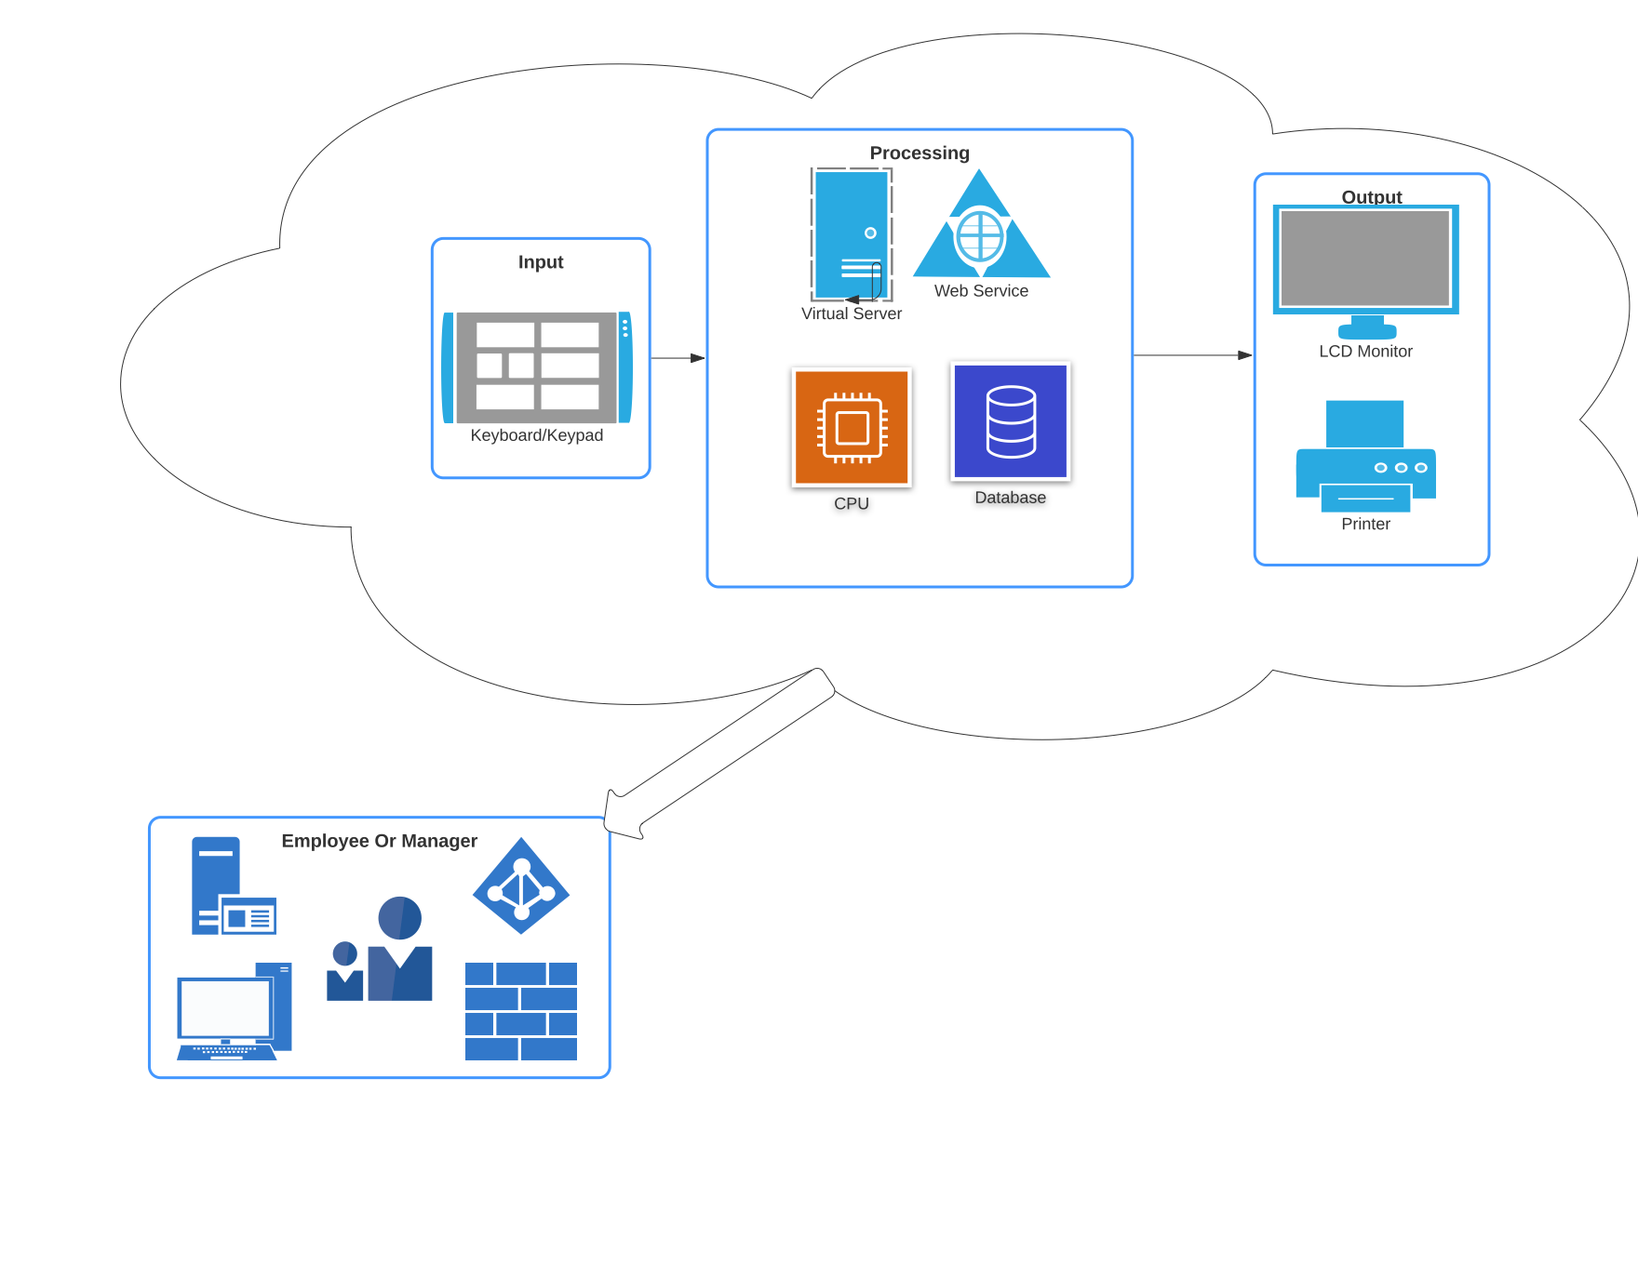
The anatomy of the modern desktop computer used by an employee has evolved now more than ever, with most company setups having computers connected to a network and sharing resources such as databases, scanners, and printers. Some companies use virtual networks instead of on premise servers, whichever set up they have the desktop computer will contain the following features in it’s anatomy.

- The CPU-central processing unit, is . CPU power determines how the device can calculate commands according to speed and size. As you enter a command with a keyboard or touchpad (mouse), the CPU instructs other computer components on how your action is performed.
- RAM - is Random Access Memory, a temporary computer memory. RAM is mostly in gigabytes and determines the capacity of the device to remember current events. The higher the RAM, the better your device will be able to operate multiple tasks and multiple loads at once. It is much faster for your device to restore something stored in its latest memory than to turn it on in the long-term memory storage of your hard drive.

- Hard Drive- Hard drives hold long-term memory stored within a computer. The space available on the hard drive continues to run out as data is stored and at the best modern computers have hard drives that can hold terabytes of data. Hard drives store all application information to make your computer work

- Motherboard: Functions almost like the computer's nervous system. Responsible for transmitting electronic data is the whole computer where the commands are inserted, easily recognized as a green circuit board coated with small power stations used for data transmission. Every computer process must go through the motherboard to start its operation.
- Graphics & Audio: There are a large number of automatic graphics cards and audio available. Video and audio output is powered by cards that are on the motherboard. They can be replaced according to specific needs. Graphic cards continue to grow every year, allowing users to see graphics closer to real life and sound in their interface.
- Monitor for display and some which are touch double as input and output devices.
Question 3
Desktop computers still possess multiple components up to date and typically they have a keyboard and mouse for input, a central processing unit, and a screen for output, newer models of the Mac and HP computers have merged the screen and the CPU with the screen sometimes being a touch too and allowing input, the common case is that we still use keyboards and mice for input. Most desktops also use AC power and hardly ever have internal batteries.
Laptops have come so far that there’s hardly a difference between them and tablets in terms of portability and size, the big difference remaining to be that laptops do tend to come with note powerful hardware as they are a bit thicker than tablets which means more laptops are generally more powerful than tablets, Laptops are still made for portability and will often include a folded screen and keyboard that is often attached but for some models can be detachable. It can be operated by battery or AC supply that makes it portable. Being able to run on both battery and AC is also a feature that is particular unique to most laptops as compared to the others. Most laptops still have touchpad and keyboards which are the primary input sources compared to tablets that have the screen as the primary input.
Tablets have the screen as the main input as well as the output and though most models can accept external input devices they’re mostly made for use through the screen. Can’t operate without batteries and the batteries are hardly ever detachable. Tables are also thinner than laptops and typically weigh less.
The main difference between phones and tablets is the screen size, tablets do seem to carry better CPUs and batteries but that’s just to match the power demand that’s higher in tablets than phones. Some phones have detachable batteries but most phones are meant for use after charge and can’t be used without batteries.

Question 4
Component | Specification
Product Number (SKU) | P22094-371
Name of the processor | Intel® Xeon® Scalable 4208 (8 core, 2.1 GHz, 11.00 MB, 85W)
Processor core available | 8 core
Processor cache | 11 MB L3
Processor speed | 2.1 GHz
Power supply type | 1 HPE 800W Flex Slot power supply
Expansion slots | 8-slots (x16, x8, x16, x8, x16, x8, x16, x8) as standard in 2P model. For detail reference QuickSpecs.
Memory, standard | 16 GB (1x 16 GB) RDIMM
Memory type | HPE DDR4 SmartMemory
Included hard drives | None ship standard, 8 SFF drives supported
Optical drive type | Optional
System fan features | 6 Standard Fans
Network controller | HPE Ethernet 1Gb 4-port 369i Adapter
Storage controller | 1 HPE Smart Array P408i-a SR Gen10 Controller
Minimum dimensions ( H x W x D) | 46.25 x 64.8 x 17.4 cm
Weight | 21 kg
Infrastructure management | HPE iLO Standard with Intelligent Provisioning (embedded), HPE OneView Standard (requires download) (standard), HPE iLO Advanced, and OneView Advanced (optional)
Pice | $1,176
Supplier | Amazon

Additional Components | Specification | Price | Number
Raid Array | LaCie 16TB 2big 2-Bay USB 3.1 Type-C RAID Array | 654 | 1
Hard Drives | HP 507613-001 1TB 7.2K RPM Hot Plug SAS Dual Port HHD W Tray | 69 | 10
Router | Huawei RH1288 V3 Server with E5-2620 V4 Processor, 16GB DDR4, 1200GB 10K SAS, SR130 Raid Card, 460W PS | 3043 | 1
UPS | APC Back-UPS Pro 1000VA UPS Battery Backup & Surge Protector | 199 | 2

Question 5
Proposed Blank Rack
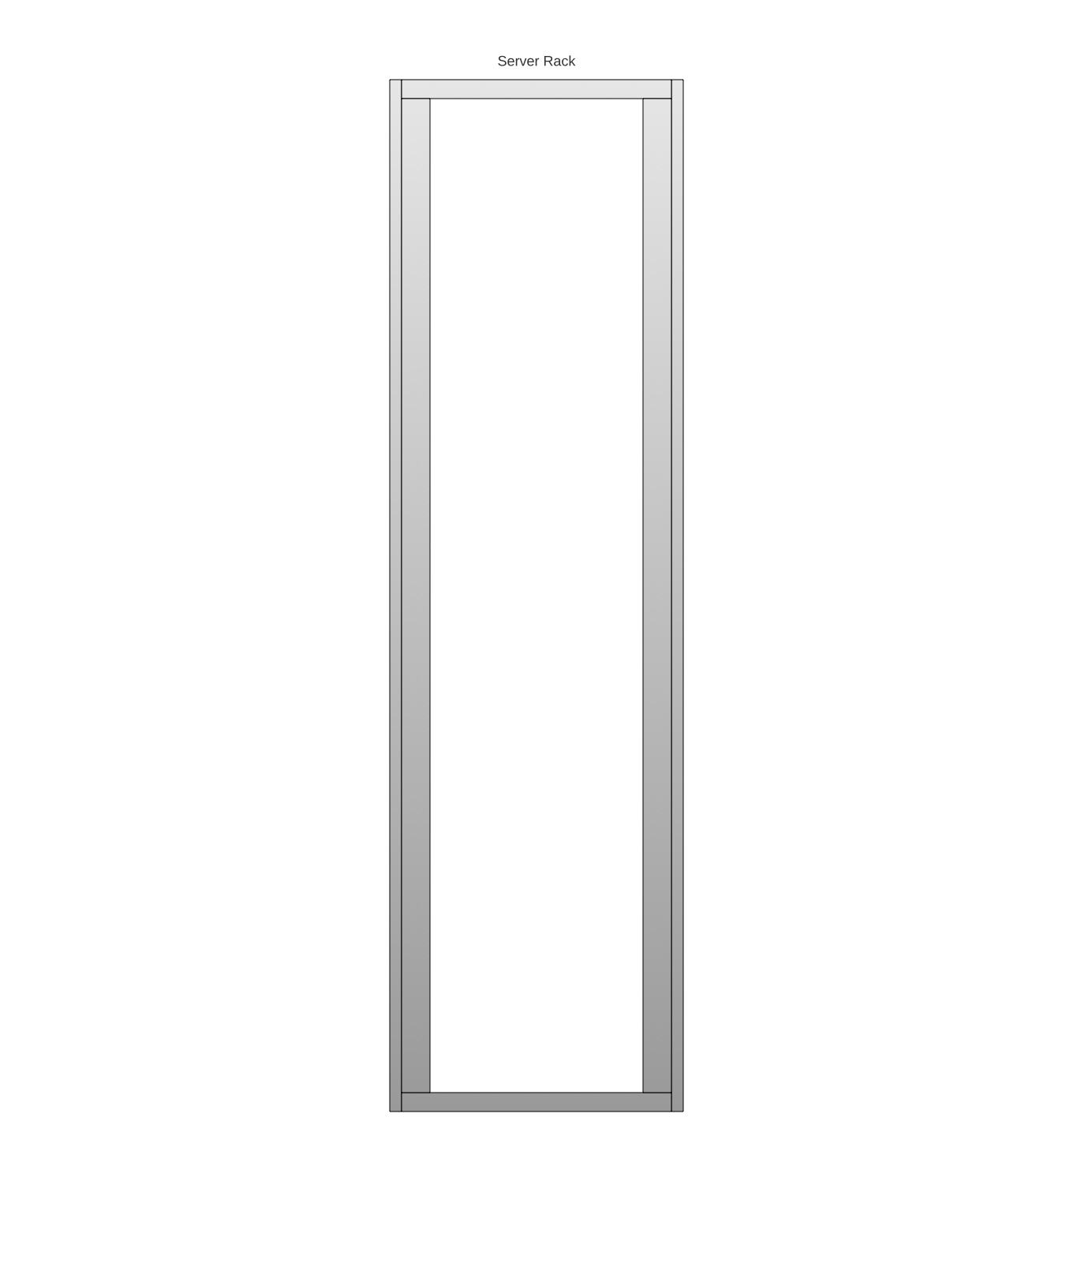

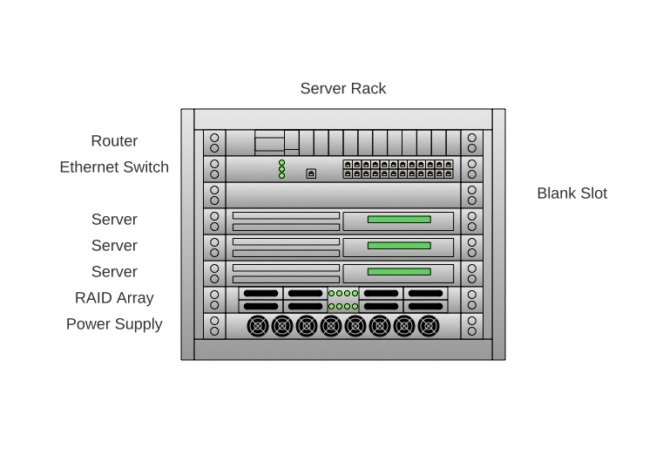
Proposed Rack with server

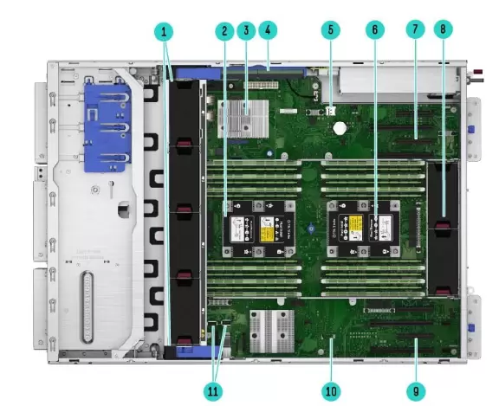
Proposed server architecture

Number | Component
1 | Redundant fan cage kit with addt’l (4) system fans are shown, supporting 2P and/or advanced cooling requirements.
2 | CPU Socket 2 with the 2ndprocessor and heatsink, (depending on server model, the 2nd processor can be Optional) and 12 DDR4 DIMM slots for RDIMM or LRDIMM
3 | HPE Smart Array Modular controller (AROC/Depending on server model, this can be Optional)
4 | HPE Smart Storage Battery(Optional depending on model)
5 | MicroSD Slot x1
6 | CPU Socket 1 with one processor and heatsink, and 12 DDR4 DIMM slots for RDIMM or LRDIMM
7 | PCIe Slots (Slot 5-8, coming from CPU2) (requires Optional 2nd processor): Slot 5 and 7 can support Optional GPU
8 | System fans: (2) fans along with the air baffle (notshown) are standard for basic cooling
9 | PCIe Slots (Slot 1-4, coming from CPU1): Slot 1 and 3 can support Optional GPU
10 | TPM Connector
11 | Internal USB port x2 (USB3.0 x1 and USB2.0 x1)

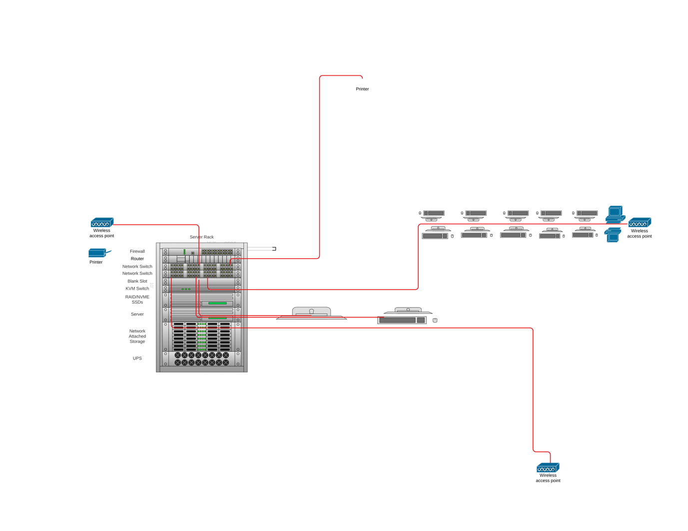
Server office network architecture

Question 6
I chose to use a server-based system, where the server would be central to all the daily operations, given that I chose this design the infrastructure has to have a raid array to ensure the client does not have downtime.
The following features will also make the server give the most value to the business as it's meant to be an investment.

- Client-server for the sharing of work involved in processing data between a client's computer and the most powerful computer. This is an implementation of distributed or collaborative processing. At the heart of the model is the idea of ​​separating app functions between client and server processors. The separation of staff between different processors enables the program designer to place the program function on the appropriate processor for that task. This allows the software designer to make use of processors, providing excellent returns on hardware investment.
- The customer-server network is the most effective way to provide:
  - Information and management of applications such as spreadsheets, accounting, communications, and document management.
  - Network management- this includes security protocols, file transfer and mail transfer within the network.
  - Medium file storage, file storage as per available allocated space is available within the network and can be used to enhance collaboration and automatic back ups straight from the server.
Given the network design was favourable to the already available resources and would also allow for the investment to remain at a manageable amount as the choice of server and hardware components was also with the thought of the size and type of industry the company is in. TEAMSTARS in itself is a company that needs storage and backups, they would prefer not to lose any designs or customer information if one or more computers are affected in the system.This server based system provides for a set up that still allows each employee to maintain their computer autonomy and softwares but still have access to the network and it’s feature and their computer still be tied to the server setups and configurations that govern the network. All this while still allowing for sharing of resources such as scanners and printers.
Access to the network will be granted once a computer is on the network and contains the right credentials to sign in. This log in will ensure administration as roles will be clearly predefined and security will apply as per, the server will also have a firewall and antivirus to ensure the company data and information is protected and in turn the employees.
The fact that all computers connect to the server through the Internet network and the existence of a raid array allows the company to avoid downtime and as long as a back up internet source is set up, it’s quite easy to keep operations running even when one provider has an internet blackout, its important to note that as long as the server and internet hardware are on, then the internal network functions will run irregardless of an internet blackout.

Bibliography
"Understanding Computers And Cognition", Google Books, 2021,
https://books.google.com/books?hl=en&lr=&id=2sRC8vcDYNEC&oi=fnd&pg=PP13&dq=understanding server computers&ots=23rwWnvlVk&sig=fhcUMB0k1efC4nOAgM8dc4fVTho.

"Understanding Computers In A Changing Society". Google Books, 2021.
https://books.google.com/books?hl=en&lr=&id=TdsKAAAAQBAJ&oi=fnd&pg=PR3&dq=understanding server computers&ots=C5F_JIRN9s&sig=AofsmDk9tVMtbekS7vj4kxNxmns

Peacecraft.Tripod.Com, 2021. https://peacecraft.tripod.com/infomining/thinclnt.pdf.

Vodafone-Chair.Org, 2021. https://www.vodafone-chair.org/media/publications/legacy/gerhard-fettweis/Pathways_to_servers_of_the_future.pdf.

"875807-B21: DL560 Gen10 6130 2P 64GB-R P408i-A 8SFF 2X1600w PS Entry Server – INET – NHÀ
PHÂN PHỐI CẤP 1: APC, ALLIED TELESIS, CISCO, PANASONIC, HP, DELL, I-RACK, UBIQUITI,…". Inetco.Com.Vn, 2021. http://inetco.com.vn/san-pham/875807-b21-dl560-gen10-6130-2p-64gb-r-p408i-a-8sff-2x1600w-ps-entry-server/.

"Understanding Computers And Cognition", Google Books, 2021, https://books.google.com/books?hl=en&lr=&id=2sRC8vcDYNEC&oi=fnd&pg=PP13&dq=understanding server computers&ots=23rwWnvlVk&sig=fhcUMB0k1efC4nOAgM8dc4fVTho.
"Understanding Computers In A Changing Society". Google Books, 2021. https://books.google.com/books?hl=en&lr=&id=TdsKAAAAQBAJ&oi=fnd&pg=PR3&dq=understanding server computers&ots=C5F_JIRN9s&sig=AofsmDk9tVMtbekS7vj4kxNxmns
"Understanding Computers In A Changing Society". Google Books, 2021. https://books.google.com/books?hl=en&lr=&id=TdsKAAAAQBAJ&oi=fnd&pg=PR3&dq=understanding server computers&ots=C5F_JIRN9s&sig=AofsmDk9tVMtbekS7vj4kxNxmns
"875807-B21: DL560 Gen10 6130 2P 64GB-R P408i-A 8SFF 2X1600w PS Entry Server – INET – NHÀ PHÂN PHỐI CẤP 1: APC, ALLIED TELESIS, CISCO, PANASONIC, HP, DELL, I-RACK, UBIQUITI,…". Inetco.Com.Vn, 2021. http://inetco.com.vn/san-pham/875807-b21-dl560-gen10-6130-2p-64gb-r-p408i-a-8sff-2x1600w-ps-entry-server/.
"875807-B21: DL560 Gen10 6130 2P 64GB-R P408i-A 8SFF 2X1600w PS Entry Server – INET – NHÀ PHÂN PHỐI CẤP 1: APC, ALLIED TELESIS, CISCO, PANASONIC, HP, DELL, I-RACK, UBIQUITI,…". Inetco.Com.Vn, 2021. http://inetco.com.vn/san-pham/875807-b21-dl560-gen10-6130-2p-64gb-r-p408i-a-8sff-2x1600w-ps-entry-server/.
"875807-B21: DL560 Gen10 6130 2P 64GB-R P408i-A 8SFF 2X1600w PS Entry Server – INET – NHÀ PHÂN PHỐI CẤP 1: APC, ALLIED TELESIS, CISCO, PANASONIC, HP, DELL, I-RACK, UBIQUITI,…". Inetco.Com.Vn, 2021. http://inetco.com.vn/san-pham/875807-b21-dl560-gen10-6130-2p-64gb-r-p408i-a-8sff-2x1600w-ps-entry-server/.
Peacecraft.Tripod.Com, 2021. https://peacecraft.tripod.com/infomining/thinclnt.pdf.
Vodafone-Chair.Org, 2021. https://www.vodafone-chair.org/media/publications/legacy/gerhard-fettweis/Pathways_to_servers_of_the_future.pdf.

